Guided Notes: Waves
Types of Waves
- ___________________ wave: oscillations are in the direction of motion (parallel to the motion)
  - Examples: ___________________________________________________________
- ___________________ Wave: oscillations are perpendicular to the direction of motion
  - Examples: ___________________________________________________________
- 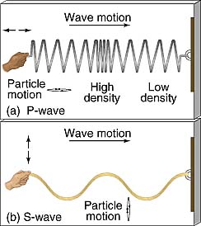
Wave Parameters
___________________ (l) length or size of one oscillation
___________________ (A) strength of disturbance (intensity)
___________________ (f) repetition / how often they occur per second
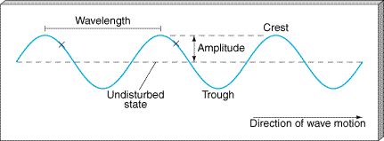
___________________ Interference
- Waves combine without any phase difference
- When they oscillate together (“in phase”)
___________________ Interference
- Waves combine differing by multiples of 1/2 wavelength

BEHAVIORS OF WAVES
4 Ways that waves interact
___________________: When a wave hits a surface through which it cannot pass, it bounces back.
___________________: Is the bending of a wave as it moves from one medium into another medium at an angle, it changes speed as it enters the second medium, which causes it to bend
- ___________________ Occurs when waves pass through a given point or medium.
example: Sound waves transmitted thru solids, liquids and gases. Radio waves are transmitted through one electron through another.
- Light waves are transmitted – 3 ways light and matter can pass through material.
A. Transparent material: Only a small amount of light is reflected or absorbed (may be clear or colored material such as filters, windows).
B. Opaque material: allows no light waves to be transmitted through them.
C. Translucent materials: Transmit some light, but cause it to be scattered so no clear image is seen.
4. ___________________
Occurs when the energy is not transferred through or reflected by the given medium
- Disappearance of an electromagnetic wave into a medium.
  - Opposite of reflection
- We see colors because of the selective absorption of visible light.
  - Objects absorb certain wavelengths and we see what is leftover.
  - The colors we see depend on the wavelength absorbed.
Electromagnetic Spectrum
___________________ waves are used to transmit radio and television signals. Radio waves have wavelengths that range from less than a centimeter to tens or even hundreds of meters.
  - ___________________ wavelength, ___________________ frequency and ___________________ amount of energy.
  - They travel long distances by reflecting their signals off Earth’s atmosphere or off satellites.
___________________ – shorter wavelengths, higher frequencies, and more energy than radio waves.
  - Cell phones and radar are two uses of microwaves.
___________________ Light - is the region of the electromagnetic spectrum that extends from the visible region to about one millimeter (in wavelength). Infrared waves include thermal radiation.
  - Associated with heat
___________________ Light – The range of EM waves that can be detected by the human eye.
  - ___________________ wavelength is of visible light is ___________________ .
  - ___________________ wavelength of visible light is ___________________ .
- The color we see is determined by the way the light interacts with the object.
  - How it is reflected and how it is transmitted.
- 400 – 700 nm (nanometers)
___________________ Light (UV)- Higher frequency than visible light and carry more energy.
  - Can damage or kill living cells
  - Tan skin by the sun or tanning bed
_____________________ - high energy waves which have great penetrating power and are used extensively in medical applications and in inspecting welds. The wavelength range is from about ten billionths of a meter to about 10 trillionths of a meter.
  - Short wavelengths and high frequencies allow them to travel through skin, but not bone (more dense)
___________________ Rays – ___________________ waves, with the ___________________ frequency (and highest energy).
  - They are more penetrating than X-rays
  - Can ___________________ living cells
  - Used to sterilize medical equipment
