Electricity and Magnetism Guided Notes
What is electricity?
The collection or flow of ___________________ in the form of an ___________________ charge
What is static electricity?
When two objects rub against each other electrons ___________________ and ___________________ on an object causing it to have a different ___________________ from its surroundings.
As electrons collect on an object, it becomes ___________________ charged. As electrons leave an object it attains a ___________________ charges. Charges interact with each other:
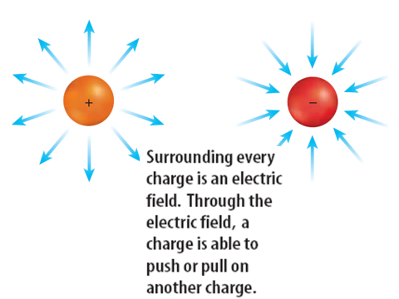
What causes you to be shocked when you rub your feet across carpet?
An electrical discharge is the passing of an electric ___________________ through the ___________________ from a negatively charged object to a positively charge object. This is what causes ___________________ !
What is a conductor and insulator?
A conductor is a material which ___________________ an electric current to pass. ___________________ are good conductors of electricity.
An insulator is a material which does ___________________ an electric current to pass. ___________________ are good conductors of electricity. Plastic, glass, wood, and rubber are good insulators

What is the difference between static electricity and current electricity?
Static electricity is ___________________ or collects on the surface of an object, whereas current electricity is flowing very rapidly through a conductor.
The ___________________ of electricity in current electricity has electrical ___________________ or ___________________ . Electric charges flow from an area of high voltage to an area of low voltage
What are batteries?
Batteries are composed of a ___________________ substance which can generate ___________________ which can be used in a circuit.
There are two kinds of batteries: ___________________ cell and ___________________ cell batteries.
What is electrical resistance?
Resistance (R)is the ___________________ to the flow of an electric current, causing the electrical energy to be converted to ___________________ energy or ___________________ .
What are electric circuits?
Circuits typically contain a voltage ___________________ , a wire ___________________ , and one or more ___________________ which use the electrical energy.
What is a series circuit?
A series circuit is one which provides a ___________________ pathway for the current to flow. If the circuit ___________________ , all devices using the circuit will ___________________ .
What is a parallel circuit?
A parallel circuit has ___________________ pathways for the current to flow. If the circuit is broken the current ___________________ pass through other pathways and other devices will ___________________ to work.

What is the difference between an open circuit and a closed circuit?
A ___________________ circuit is one in which the pathway of the electrical current is complete and unbroken.
An ___________________ circuit is one in which the pathway of the electrical current is broken. A switch is a device in the circuit in which the circuit can be closed (turned on) or open (turned off).
What is magnetism?
Magnetism is the ___________________ and ___________________ of magnets
The earliest magnets were found naturally in the mineral magnetite which is abundant the rock-type lodestone. These magnets were used by the ancient peoples as compasses to guide sailing vessels.
Magnets produce magnetic ___________________ and have magnetic ___________________ lines
Magnets have two ends or ___________________ , called north and south poles. At the poles of a magnet, the magnetic field lines are ___________________ together.
What are magnetic domains?
Magnetic substances like iron, cobalt, and nickel are composed of small areas where the groups of atoms are aligned like the poles of a magnet. These regions are called domains. All of the domains of a magnetic substance tend to align themselves in the same direction when placed in a magnetic field. These domains are typically composed of billions of atoms.
Electricity and Magnetism – how are they related?
When an electric current passes through a ___________________ a magnetic field is ___________________ .
What is an electromagnet?
When an electric current is passed through a ___________________ of wire wrapped around a metal core, a very ___________________ magnetic field is produced. This is called an ___________________ .

What are electric motors?
An electric motor is a device which changes ___________________ energy into ___________________ energy.
What is electromagnetic induction?
Moving a ___________________ of wire through a ___________________ field produces an ___________________ current. This is electromagnetic induction.
A ___________________ is used to convert mechanical energy into electrical energy by electromagnetic induction.
Direct current versus alternating current – AC vs DC : What’s the difference?
___________________ current is electrical current which comes from a ___________________ which supplies a ___________________ flow of electricity in one direction.
___________________ current is electrical current which comes from a ___________________ . As the electromagnet is rotated in the permanent magnet the direction of the current ___________________ once for every revolution.

