Name:: _____________________________
Guided Notes: Color and Light
- The only thing we can hear is sound. The only thing we can see is light
How do we see color?
The color of an object is ___________________________ within the object itself. Rather, the color is in the light that shines upon it and is ultimately reflected to our eyes.
- When visible light strikes an object and a specific ___________________________ becomes ___________________________, that frequency of light will ___________________________ make it to our eyes.
- Any visible light that strikes the object and becomes ___________________________ to our eyes will contribute to the color appearance of that object. So the color is not in the object itself, but in the light that strikes the object and ultimately reaches our eye.
Check your understanding:
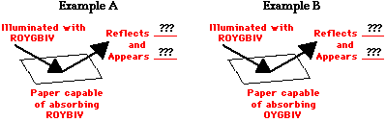
Transparent Objects
- Transparent materials allow one or more of the ___________________________ of visible light to be transmitted through them; whatever colors are not transmitted are typically absorbed by them. The appearance of a transparent object is dependent upon what colors of light are incident upon the object and what colors of light are ___________________________ through the object.
Check your understanding
