Name: _________________________________
Guided Notes: Earthquakes
What are earthquakes?
- Natural _______________________ in the ground caused by:
  - Plate movement along giant fractures
  - Volcanic activity
What causes earthquakes?
- _______________________ : the force applied to a rock exceeds its strength
- _______________________ : the deformation causes by stress
- 3 types: Compression, Tension, Shear
How do earthquakes travel?
- In _______________________ waves!
  - Seismo- (Greek) “to shake”
- P-waves
  - Primary (1st)
  - Pulls rocks in the _______________________ direction as the wave
  - Body waves (occur inside earth)
- S-waves
  - Secondary
  - Causes rocks to move _______________________ to the wave
  - Body waves (occur inside earth)
- L-waves
  - Third to arrive
  - Move in _______________________ directions
    - Up and down
    - Side to side
  - Surface waves (MOST destructive!)
How do earthquakes travel?
- Body waves spread out from the earthquakes origin, or _______________________
- On the surface above the focus, is the _______________________
How do we detect earthquakes?
- _______________________ : sensitive tools that can detect and record vibrations at great distances from epicenters…even though we can’t feel them!
- Many years of data from facilities around the world has allowed seismologists to construct global time-travel curves for P-waves and S-waves
- This allows us to predict earthquake patterns, no matter where in the world the epicenter is!
- Y-axis= Time
- X-axis= Distance
- P-waves ALWAYS travel quicker than S-waves
- Time lag= amount of time between P-waves and S-waves (increases with time)
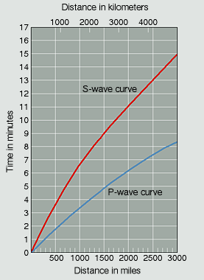
How do we monitor seismic activity?
- _______________________ movements near a fault are a clue that an earthquake might happen. So, scientists measure ground movements near faults.
- They use tiltmeters, creep meters, laser-ranging devices, and GPS satellites
- _______________________ show how much the ground is tilting, or tipping.
  - Works like a carpenter’s level—water inside a glass bulb shows how much tilting there is.
- _______________________ meters show how far the sides of a fault have moved in opposite directions.
  - Uses a wire stretched across a fault—gets longer when the two sides move apart.
- _______________________ devices use a laser beam to detect horizontal fault movement.
  - Device times a laser beam as it travels to a reflector and back and tracks change
- To use the _______________________ , scientists put super-sensitive markers along both sides of the fault
How are earthquakes measured?
- By the amount of energy released or _______________________
  - Measured on the Richter Scale
- By the amount of damage done or _______________________
  - Measured on the Mercalli Scale
- Some earthquakes aren’t even felt while others wipe out entire cities!
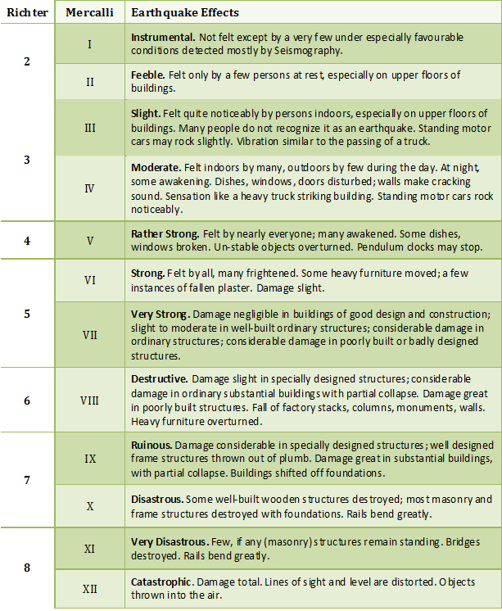
Write a “T” for true or a “F” for false beside each statement about measuring earthquakes.
- Earthquakes that are a 1 on the Richter Scale and Mercalli Scale can only be felt at the epicenter.
- The Richter Scale measures the amount of damage done by an earthquake.
- The highest magnitude on the Mercalli Scale is 15.
- On the Richter Scale, each number represents a 10x increase in energy released.

