Name: ____________________________________
Guided Notes: Earthquakes and the Earth’s Interior
Earthquakes
An _____________________ is the vibration of Earth produced by the rapid release of energy
Focus and Epicenter
• _____________________ is the point within Earth where the earthquake starts.
• _____________________ is the location on the surface directly above the focus.
Faults
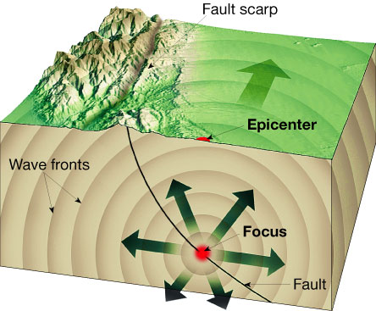
• _____________________ are fractures in Earth where movement has occurred.

Cause of Earthquakes
Elastic Rebound Hypothesis
• Most earthquakes are produced by the rapid release of elastic _____________________ stored in rock that has been subjected to great forces.
• When the strength of the rock is exceeded, it suddenly breaks, causing the vibrations of an earthquake.
Aftershocks and Foreshocks
• An _____________________ is a small earthquake that follows the main earthquake.
• A _____________________ is a small earthquake that often precedes a major earthquake.

Earthquake Waves
_____________________ are instruments that record earthquake waves.
_____________________ are traces of amplified, electronically recorded ground motion made by seismographs.
_____________________ are seismic waves that travel along Earth’s outer layer.
_____________________
• Identified as P waves or S waves
• P waves
- Are push-pull waves that push (compress) and pull (expand) in the direction that the waves travel
- Travel through solids, liquids, and gases
- Have the greatest velocity of all earthquake waves
• S waves
- Seismic waves that travel along Earth’s outer layer
- Shake particles at right angles to the direction that they travel
- Travel only through solids
- Slower velocity than P waves
A seismogram shows all three types of seismic waves—surface waves, P waves, and S waves.
Locating an Earthquake
Earthquake Distance
• The _____________________ is located using the difference
in the arrival times between P and S wave
recordings, which are related to distance.
Earthquake Direction
• Travel-time graphs from three or more seismographs can be used to find the exact location of an earthquake epicenter.
Earthquake Zones
• About _____________________ percent of the major earthquakes occur in a few narrow zones.

Measuring Earthquakes
Historically, scientists have used two different types of measurements to describe the size of an earthquake
—_____________________ and _____________________ .
Richter Scale
• Based on the _____________________ of the _____________________ seismic
wave
• Each unit of Richter magnitude equates to roughly a _____________________ energy increase
• Does not estimate adequately the size of very large earthquakes
Momentum Magnitude
• Derived from the amount of _____________________ that occurs along the fault zone
• Moment magnitude is the most widely used measurement for earthquakes because it is the only magnitude scale that estimates the energy released by earthquakes.
• Measures very large earthquakes
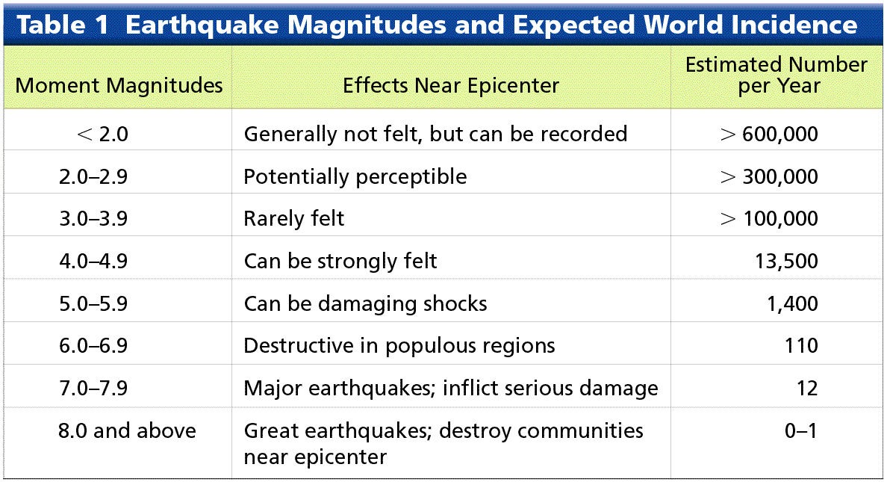

Seismic Vibrations
The damage to buildings and other structures from earthquake waves depends on several factors. These factors include the intensity and duration of the vibrations, the nature of the material on which the structure is built, and the design of the structure.
Building Design
• Factors that _____________________ structural damage
- Intensity of the earthquake
- Unreinforced stone or brick buildings are the most _____________________ safety threats
- Nature of the _____________________ upon which the structure rests
- The _____________________ of the structure
Liquefaction
• Saturated material turns _____________________
• Underground objects may float to surface
Tsunamis
Cause of Tsunamis
• A _____________________ triggered by an earthquake occurs where a slab of the ocean floor is displaced vertically along a fault.
• A tsunami also can occur when the vibration of a quake sets an underwater landslide into motion.
• Tsunami is the Japanese word for “seismic sea wave.”
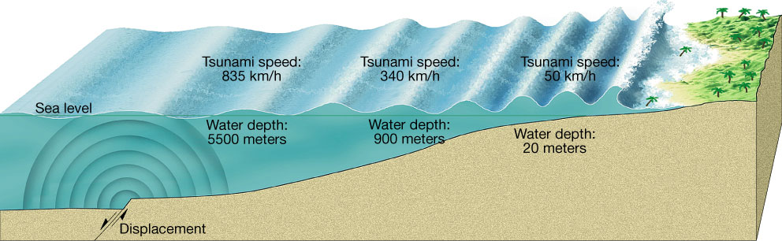

Tsunami Warning System
• Large earthquakes are reported to Hawaii from Pacific seismic stations.
• Although tsunamis travel quickly, there is sufficient time to _____________________ all but the area closest to the epicenter.
Other Dangers
Landslides
• With many earthquakes, the greatest damage
to structures is from _____________________ and ground subsidence, or the _____________________ of the ground triggered by vibrations.
Fire
• In the San Francisco earthquake of 1906, most
of the destruction was caused by _____________________ that started when gas and electrical lines were cut.

Predicting Earthquakes
Short-Range Predictions
• So far, methods for short-range predictions of earthquakes have _____________________ successful.
Long-Range Forecasts
• Scientists don’t yet understand enough about how and where earthquakes will occur to make _____________________ long-term predictions.
• A _____________________ is an area along a fault where there has not been any earthquake activity for a long period of time.
Layers Defined by Composition
Earth’s interior consists of three major zones defined by their chemical composition—the crust, mantle, and core.
_____________________
• _____________________ , rocky outer layer
• Varies in thickness
- Continental crust averages 8–40 km
- Roughly 7 km in oceanic regions
- Exceeds 70 km in mountainous regions
• _____________________ crust
- Upper crust composed of granitic rocks
- Lower crust is more akin to basalt
- Average density is about 2.7 g/cm³
- Up to 4 billion years old
• _____________________ crust
- Basaltic composition
- Density about 3.0 g/cm³
- _____________________ (180 million years or less) than the continental crust
_____________________
• Below _____________________ to a depth of 2900 kilometers
• Composition of the uppermost mantle is the _____________________ rock peridotite (changes at greater depths).
_____________________
• Below _____________________
• Sphere with a radius of 3486 kilometers
• Composed of an _____________________ alloy
• Average density of nearly 11 g/cm³
Layers Defined by Physical Properties
_____________________
• Crust and uppermost mantle (about 100 km thick)
• Cool, rigid, solid
_____________________
• Beneath the lithosphere
• Upper _____________________
• To a depth of about 660 kilometers
• Soft, weak layer that is easily deformed
_____________________
• 660–2900 km
• More rigid layer
• Rocks are very hot and capable of gradual flow.
_____________________
• Sphere with a radius of 1216 km
• Behaves like a _____________________
_____________________
• _____________________ layer
• 2270 km thick
• Convective flow of metallic iron within generates Earth’s magnetic field

Discovering Earth’s Layers
_____________________
• Velocity of seismic waves increases abruptly below 50 km of depth
• Separates _____________________ from underlying _____________________
Shadow Zone
• Absence of P waves from about 105 degrees to 140 degrees around the globe from an earthquake
• Can be explained if Earth contains a core composed of materials unlike the overlying mantle
Crust
• Early seismic data and drilling technology indicate that the continental crust is mostly made of lighter, granitic rocks.
Mantle
• Some of the lava that reaches Earth’s surface comes from asthenosphere within.
• Composition is more speculative.
Core
• Earth’s core is thought to be mainly dense iron and nickel, similar to metallic meteorites. The surrounding mantle is believed to be composed of rocks similar to stony meteorites.

