Name: ___________________________
Guided Notes: Earth’s History
Precambrian History
- The Precambrian encompasses immense geological time, from Earth’s distant beginnings 4.56 billion years ago until the start of the Cambrian period, over 4 billion years later.
- Precambrian Rocks
  - ____________________ are large, relatively flat expanses of ancient metamorphic rock within the stable continental interior
  - Much of what we know about Precambrian rocks comes from ores mined from shields
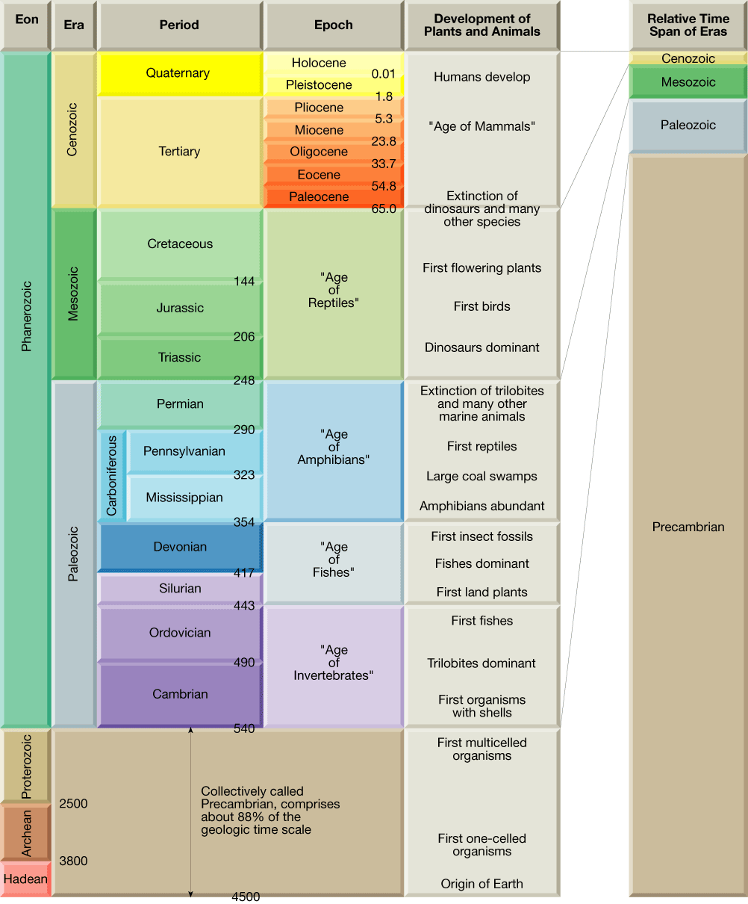

- Earth’s Atmosphere Evolves
  - Earth’s original atmosphere was made up of gases similar to those released in volcanic eruptions today—water vapor, carbon dioxide, nitrogen, and several trace gases, but no ____________________
  - Later, primary plants evolved that used ____________________ and released oxygen
  - ____________________ began to accumulate in the atmosphere about 2.5 billion years ago.
- Precambrian Fossils
  - The most common Precambrian fossils are stromatolites
  - ____________________ are distinctively layered mounds or columns of calcium carbonate. They are not the remains of actual organisms but are the material deposited by algae
  - Many of these ancient fossils are preserved in ____________________ —a hard dense chemical sedimentary rock

Early Paleozoic
- Following the long Precambrian, the most recent ____________________ million years of Earth’s history are divided into three eras: Paleozoic, Mesozoic, and Cenozoic.
- During the Cambrian, Ordovician, and Silurian periods, the vast southern continent of ____________________ encompassed five continents (South America, Africa, Australia, Antarctica, and part of Asia).
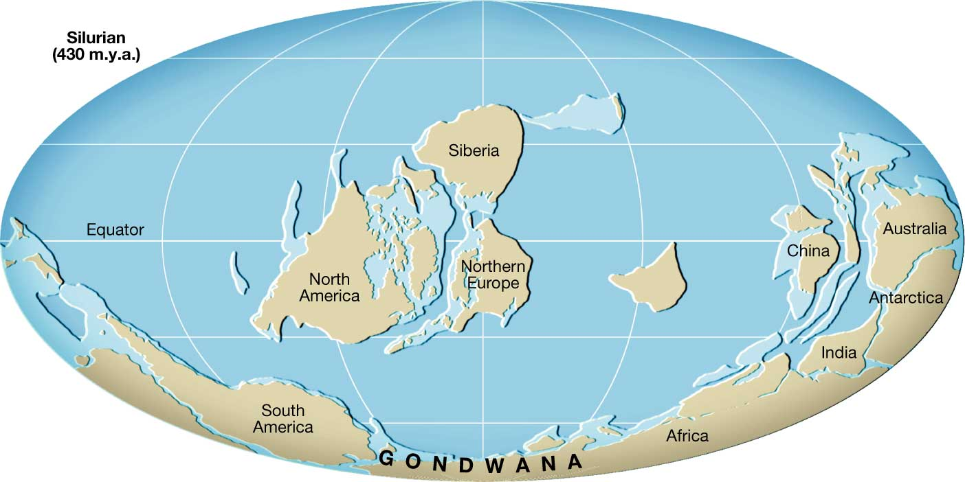

- Early Paleozoic Life
  - • Life in early Paleozoic time was restricted to the ____________________.
- Late Paleozoic History
  - ____________________ is the continental mass that formed the northern portion of Pangaea, consisting of present-day North America and Eurasia
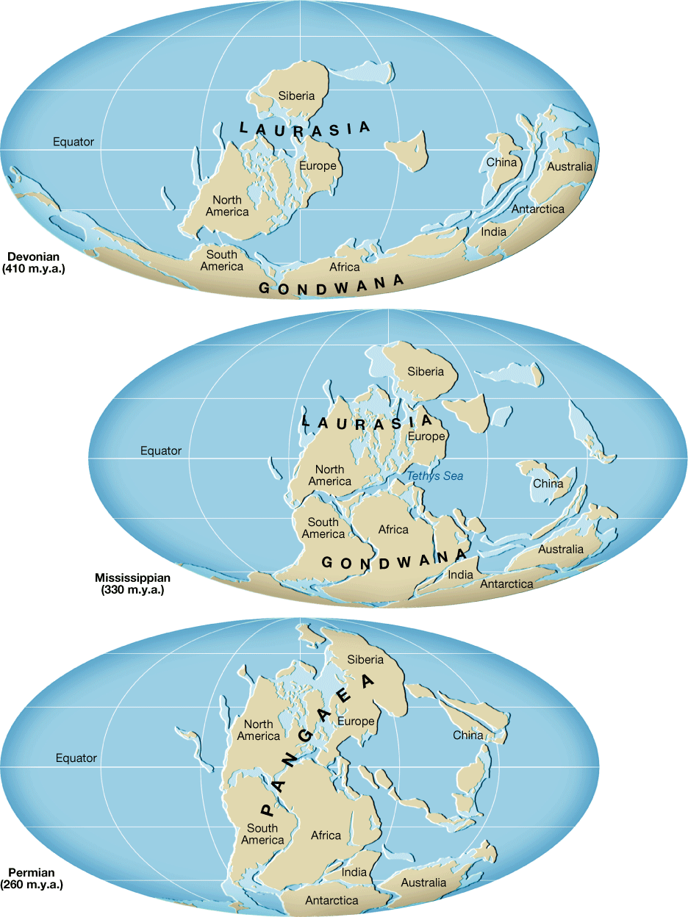
  - By the end of the Paleozoic, all the continents had fused into the supercontinent of ____________________ _

Late Paleozoic
- Late Paleozoic Life
  - Some ____________________ million years ago, plants that had adapted to survive at the water’s edge began to move inland, becoming land plants
  - The amphibians rapidly diversified because they had minimal competition from other land dwellers.
The Great Paleozoic Extinction
- The world’s climate became very seasonal, probably causing the dramatic ____________________ of many species.
- The late Paleozoic extinction was the greatest of at least ____________________ mass extinctions to occur over the past 500 million years
Mesozoic Era
- ____________________ were land-dwelling reptiles that thrived during the Mesozoic era
- Mesozoic History
  - A major event of the Mesozoic era was the breakup of Pangaea.
- Mesozoic Life
  - ____________________ are seed-bearing plants that do not depend on free-standing water for fertilization
  - The gymnosperms quickly became the dominant plants of the Mesozoic era
- The Shelled Egg
  - Unlike amphibians, reptiles have ____________________ eggs that can be laid on the land.
  - The elimination of a water-dwelling stage (like the tadpole stage in frogs) was an important evolutionary step.
- Reptiles Dominate
  - With the perfection of the shelled egg, reptiles quickly became the dominant land animals
  - At the end of the ____________________ era, many reptile groups became extinct
Cenozoic North America
- The ____________________ era is divided into two periods of very unequal duration, the Tertiary period and the Quaternary period
- ____________________ interactions during the Cenozoic era caused many events of mountain building, volcanism, and earthquakes in the West

Cenozoic Life
- ____________________ —animals that bear live young and maintain a steady body temperature— replaced reptiles as the dominant land animals in the Cenozoic era.
- ____________________ —flowering plants with covered seeds—replaced gymnosperms as the dominant land plants.
- Mammals Replace Reptiles
  - ____________________ like being warm blooded, developing insulating body hair, and having more efficient heart and lungs allow mammals to lead more active lives than reptiles
- Large Mammals and Extinction
  - In North America, the ____________________ and ____________________, both huge relatives of the elephant, became extinct. In addition, saber-toothed cats, giant beavers, large ground sloths, horses, camels, giant bison, and others died out on the North American continent.
  - The reason for this recent wave of extinctions puzzles scientists

