Name: ________________________________
Guided Notes: Geologic Time
Rocks Record Earth History
- Rocks record geological events and changing life forms of the past.
- We have learned that Earth is much older than anyone had previously imagined and that its surface and interior have been changed by the same geological processes that continue today.
A Brief History of Geology
- _____________________ means that the forces and processes that we observe today have been at work for a very long time
Relative Dating—Key Principles
- _____________________ tells us the sequence in which events occurred, not how long ago they occurred
- Law of Superposition
  - The law of _____________________ states that in an undeformed sequence of sedimentary rocks, each bed is older than the one above it and younger than the one below it.
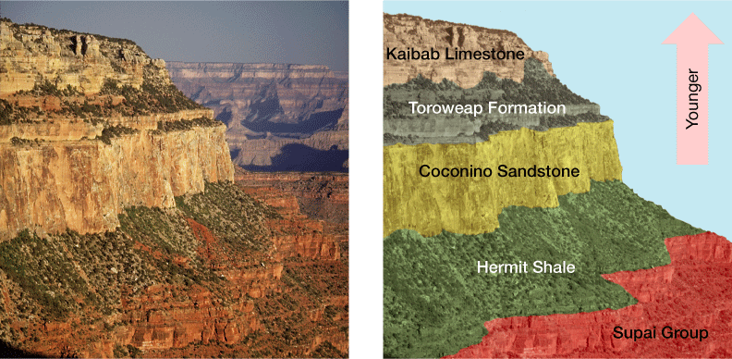

- The principle of original _____________________ means that layers of sediment are generally deposited in a horizontal position.
- The principle of _____________________ relationships states that when a fault cuts through rock layers, or when magma intrudes other rocks and crystallizes, we can assume that the fault or intrusion is younger than the rocks affected.
- _____________________ are rocks contained within other rocks.
- Rocks containing inclusions are younger than the inclusions they contain.
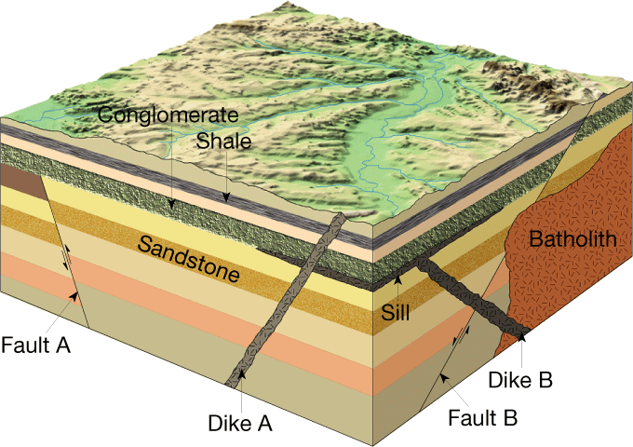

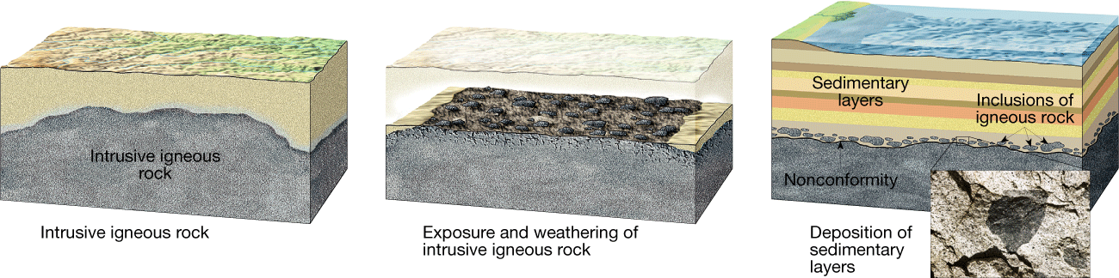

- Unconformities
  - An _____________________ represents a long period during which deposition stopped, erosion removed previously formed rocks, and then deposition resumed.
  - An _____________________ unconformity indicates that during the pause in deposition, a period of deformation (folding or tilting) and erosion occurred
- A _____________________ is when the erosional surface separates older metamorphic or intrusive igneous rocks from younger sedimentary rocks.
- A _____________________ is when two sedimentary rock layers are separated by an erosional surface.

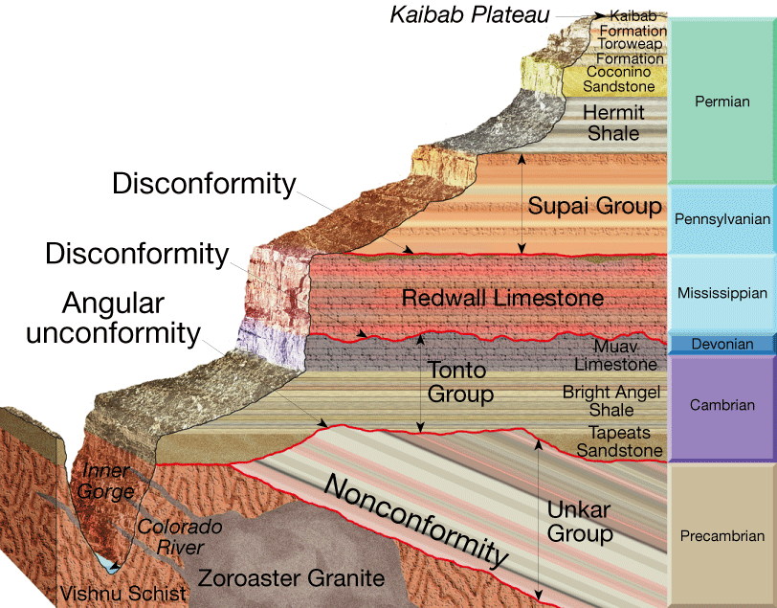

Correlation of Rock Layers
- _____________________ is establishing the equivalence of rocks of similar age in different areas.
Fossil Formation
- _____________________ are the remains or traces of prehistoric life. They are important components of sediment and sedimentary rocks.
- The type of fossil that is formed is determined by the _____________________ under which an organism died and how it was buried
- _____________________ Remains
  - Some remains of organisms—such as teeth, bones, and shells—may not have been altered, or may have changed hardly at all over time.
- _____________________ Remains
  - The remains of an organism are likely to be changed over time.
  - Fossils often become petrified or turned to stone.
  - Molds and casts are another common type of fossil
  - Carbonization is particularly effective in preserving leaves and delicate animals. It occurs when an organism is buried under fine sediment
- _____________________ Evidence
  - Trace fossils are indirect evidence of prehistoric life.
  - Conditions Favoring Preservation
  - Two conditions are important for preservation: rapid burial and the possession of hard parts.
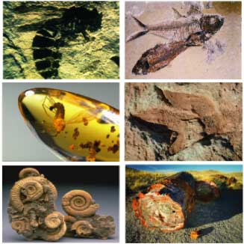

Fossils and Correlation
- The principle of fossil succession states that fossil organisms succeed one another in a definite and determinable _____________________. Therefore, any _____________________ can be recognized by its fossil content
- _____________________ fossils are widespread geographically, are limited to a short span of geologic time, and occur in large numbers
- Fossils can also be used to interpret and describe ancient environments.

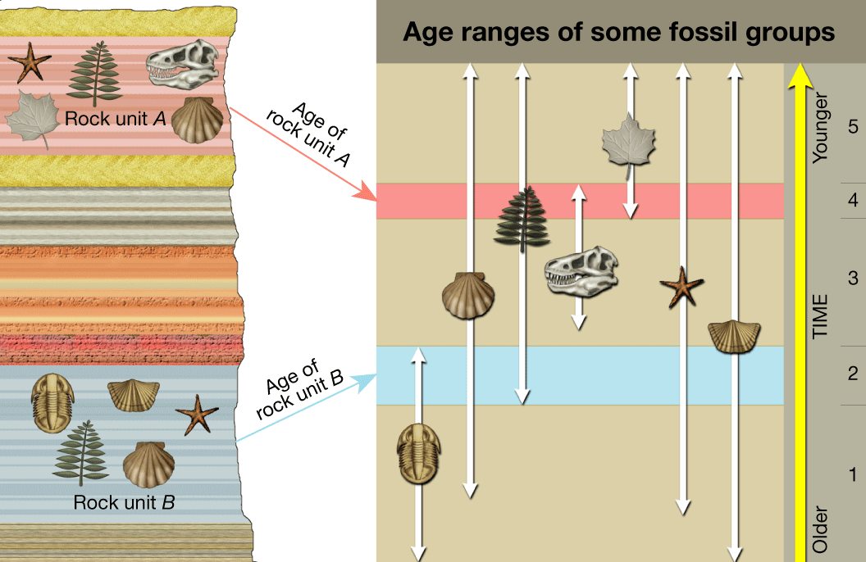

Structure of the Time Scale
- Based on their interpretations of the rock record, geologists have divided Earth’s 4.56-billion-year history into units that represent specific amounts of time. Taken together, these time spans make up the geologic time scale
- _____________________ represent the greatest expanses of time.
  - Eons are divided into _____________________.
  - Each era is subdivided into _____________________.
  - Finally, periods are divided into smaller units called _____________________
- There are three eras within the Phanerozoic eon:
  - the _____________________, which means “ancient life,”
  - the _____________________, which means “middle life,” and the
  - _____________________, which means “recent life.”
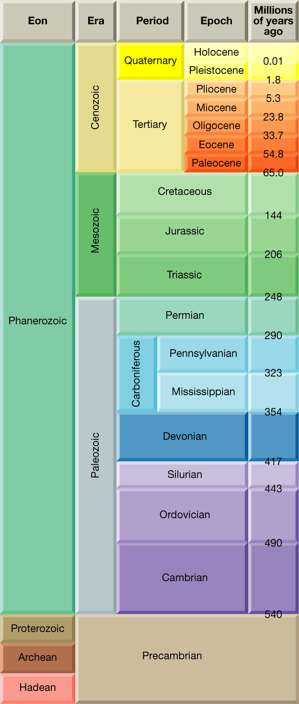
- Each period within an era is characterized by somewhat less profound _____________________ in life forms as compared with the changes that occur during an era
- The periods of the _____________________ era are divided into still smaller units called epochs, during which even less profound changes in life forms occur.

