Name: __________________________________
Guided Notes: Eath’s Plates
Structure of the Earth
The Earth is made up of 3 main layers:
- _____________________________
- _____________________________
- _____________________________
The Crust
_____________________________ Crust
- thick (10-70km)
- buoyant (less dense than oceanic crust)
- mostly old
_____________________________ Crust
- - thin (~7 km)
- dense (sinks under continental crust)
- young
Plate Tectonics
- The Earth’s crust is divided into 12 major plates which are moved in various directions.
- This plate motion causes them to _____________________________, pull apart, or scrape against each other.
- Each type of interaction causes a characteristic set of Earth structures or “tectonic” features.
- The word, tectonic, refers to the deformation of the crust as a consequence of plate interaction.
What are tectonic plates made of?
- Plates are made of rigid _____________________________
- The lithosphere is made up of the crust and the upper part of the ____________________________
Plate Movement
- “Plates” of lithosphere are moved around by the underlying hot mantle convection cells
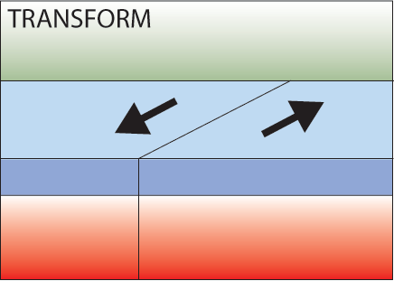
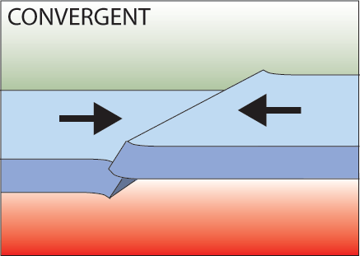
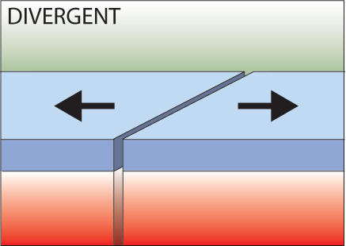
- Divergent
- Convergent
- Transform

Divergent Boundaries
- _____________________________ ridges
  - As plates move apart new material is erupted to fill the gap
Convergent Boundaries
- There are three styles of convergent plate boundaries
  - Continent-_____________________________ collision
  - Continent-_____________________________ crust collision
  - Ocean-_____________________________ collision
- Subduction
  - Oceanic lithosphere subducts underneath the continental lithosphere
  - Oceanic lithosphere heats and dehydrates as it subsides
  - The melt rises forming volcanism
  - E.g. The Andes
Transform Boundaries
- Where plates _____________________________ past each other
Volcanoes are formed by:
- Subduction
- Rifting
- Hotspots

