Guided Notes: Rocks
Rocks
- ____________________ are any solid mass of mineral or mineral-like matter occurring naturally as part of our planet.
Types of Rocks
1. ____________________ rock is formed by the crystallization of molten magma.
2. ____________________ rock is formed from the weathered products of preexisting rocks that have been transported, deposited, compacted, and cemented.
3. ____________________ rock is formed by the alteration of pre-existing rock deep within Earth (but still in the solid state) by heat, pressure, and/or chemically active fluids.
The Rock Cycle
- Shows the interrelationships among the three rock types (igneous, sedimentary, and metamorphic)
- ____________________ is molten material that forms deep beneath the Earth’s surface.
- ____________________ is magma that reaches the surface.
- ____________________ is a process in which rocks are broken down by water, air, and living things.
- ____________________ is weathered pieces of Earth elements.

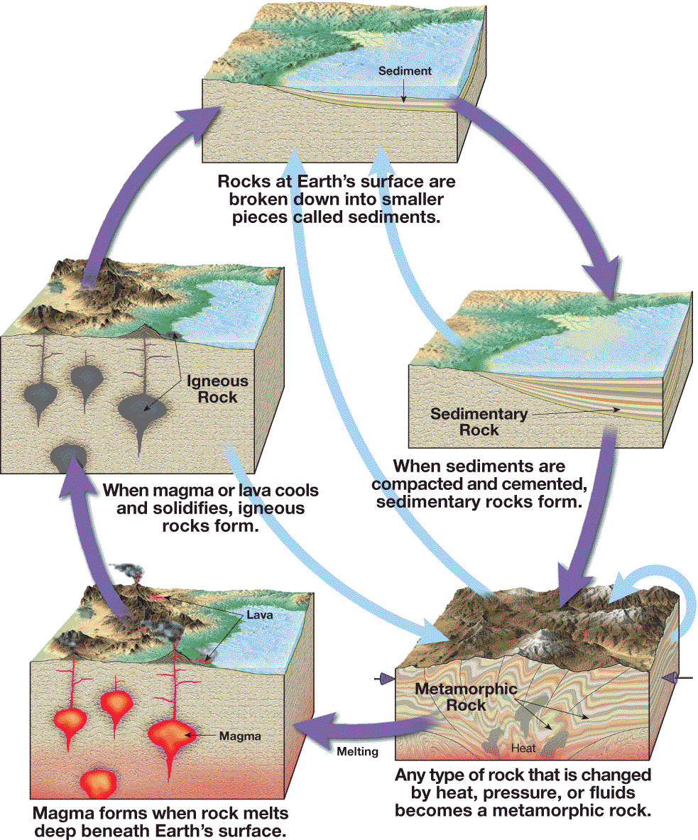

Energy That Drives the Rock Cycle
- Processes driven by heat from the Earth’s ____________________ are responsible for forming both igneous rock and metamorphic rock.
- Weathering and the movement of weathered materials are ____________________ processes powered by energy from the sun.
- External processes produce ____________________ rocks.
Formation of Igneous Rocks
1. ____________________ igneous rocks are formed when magma hardens beneath Earth’s surface.
2. ____________________ igneous rocks are formed when lava hardens.
Classification of Igneous Rocks
- Igneous rocks can be classified based on their composition and texture.
1. ____________________
• Coarse-grained texture is caused by ____________________ cooling resulting in larger crystals.
• Fine-grained texture is caused by ____________________ cooling resulting in smaller, interconnected mineral grains.
• Porphyritic texture is caused by different rates of cooling resulting in varied sized minerals.
2. Composition
• Granitic composition rocks are made mostly of light-colored quartz and feldspar.
• Basaltic composition rocks are made mostly of dark-colored silicate minerals and plagioclase feldspar.
• Andesitic composition rocks are between granitic light-color minerals and basaltic composition dark-colored minerals.
• Ultramafic composition rocks are made mostly from iron and magnesium-rich minerals.
Formation of Sedimentary Rocks
- Weathering, Erosion, and Deposition
• ____________________ involves the weathering and the removal of rock.
• ____________________ occurs when an agent of erosion—water, wind, ice, or gravity—loses energy and drops sediments.
- Compaction and Cementation
• ____________________ is a process that squeezes, or compacts, sediments.
• ____________________ takes place when dissolved minerals are deposited in the tiny spaces among the sediments.

Classification of Sedimentary Rocks
- Two Main Groups
1. ____________________ sedimentary rocks are composed of weathered bits of rocks and minerals.
• Classified by particle size
• Common rocks include
- Shale (most abundant)
- Sandstone
- Conglomerate
2. Chemical sedimentary rocks form when dissolved substances precipitate, or separate, from water.
- Common rocks include
  - limestone—most abundant chemical rock
  - microcrystalline quartz known as chert, flint, jasper, or agate
  - evaporites such as rock salt or gypsum
  - coal
Formation of Metamorphic Rocks
- ____________________ means “to change form.”
- Most metamorphic changes occur at elevated temperatures and pressures.
- Conditions for formation are found a few kilometers below the Earth’s surface and extend into the upper mantle.
- Contact metamorphism occurs when magma moves into rock.
- Occurs near a body of ____________________
- Changes are driven by a rise in ____________________.
- Regional metamorphism results in large-scale deformation and high-grade metamorphism.
- Directed pressures and high temperatures occur during ____________________ building.
- Produces the greatest ____________________ of metamorphic rock

Agents of Metamorphism
____________________
- Provides the energy needed to drive chemical reactions
____________________
- Causes a more compact rock with greater density
Hydrothermal Solutions
- Hot ____________________ -based solutions escaping from the mass of magma
- Promote recrystallization by dissolving original minerals and then depositing new ones
Classification of Metamorphic Rocks
1. ____________________ Metamorphic Rock
  - Has a banded or layered appearance
2. ____________________ Metamorphic Rock
  - Does not have a banded texture

